

**Health and Safety Handbook**

**February 2023**



**CONTENTS**

INTRODUCTION 4

HEALTH AND SAFETY POLICY STATEMENT 5

RESPONSIBILITIES AND RULES 6

Employee Responsibilities 6

Health and Safety Rules 7

General 7

Working Practices 7

Hazard / Warning Signs and Notices 7

Working Conditions / Environment 7

Protective Clothing and Equipment 8

Fire Precautions 8

Accidents 8

Health 8

Rules Covering Gross Misconduct 9

ARRANGEMENTS FOR HEALTH AND SAFETY 10

Accident, Incident and Ill-Health Recording, Reporting and Investigation 10

Asbestos 10

Communication and Consultation 10

Contractors 11

Disabled Persons 11

Display Screen Equipment 11

Driving for Work 12

Electricity 13

Fire 14

Fire and Emergency Evacuation 16

First Aid 17

Gas Installations and Appliances 17

Hazardous Substances (COSHH) 18

Health, Safety and Welfare 18

Home Working 19

Infection Control 19

Legionnaires’ Disease 20

Lone Working 20

Manual Handling 21

New and Expectant Mothers 21

Personal Protective Equipment 21

Risk Assessment 22

Smoking 22

Stress at Work 22

Training 23

Violence to Staff 23

Visitors 24

Work At Height 24

Work Equipment 25

Young Workers 25

GUIDANCE 26

Control of Substances Hazardous to Health (COSHH) 26

Display Screen Equipment (DSE)/Visual Display Unit (VDU) 28

Electrical Safety 30

Hand Washing 31

Manual Handling 32

HEALTH AND SAFETY HANDBOOK ACKNOWLEDGEMENT FORM 35

|  |
| --- |
| INTRODUCTION |

This handbook contains the health and safety information you require to comply with our Health and Safety Policy. After reading it you will be required to sign to confirm that it has been brought to your attention. If you have any queries regarding the contents please do not hesitate to ask.

Barmoor Hub takes its responsibility for health and safety very seriously and is committed to a programme of progressive improvement that requires input from all its employees. If you see anything during your work that gives rise to a concern you are positively encouraged to report it to your supervisor or manager.

Safety is everyone’s responsibility and that includes you.

|  |
| --- |
| HEALTH AND SAFETY POLICY STATEMENT |

The management of Barmoor Hub recognises that it has a legal duty of care towards protecting the health and safety of its employees and others who may be affected by the charity’s activities, and that managing health and safety is a business critical function.

In order to discharge its responsibilities the management will:

* bring this Policy Statement to the attention of all employees
* carry out and regularly review risk assessments to identify proportionate and pragmatic solutions to reducing risk
* communicate and consult with our employees on matters affecting their health and safety
* comply fully with all relevant legal requirements, codes of practice and regulations at International, National and Local levels
* eliminate risks to health and safety, where possible, through selection and design of materials, buildings, facilities, equipment and processes
* encourage staff to identify and report hazards so that we can all contribute towards improving safety
* ensure that emergency procedures are in place at all locations for dealing with health and safety issues
* maintain our premises, provide and maintain safe plant and equipment
* only engage contractors who are able to demonstrate due regard to health & safety matters
* provide adequate resources to control the health and safety risks arising from our work activities
* provide adequate training and ensure that all employees are competent to do their tasks
* provide an organisational structure that defines the responsibilities for health and safety
* provide information, instruction and supervision for employees
* regularly monitor performance and revise policies and procedures to pursue a programme of continuous improvement.

This Health and Safety Policy will be reviewed at least annually and revised as necessary to reflect changes to the business activities and any changes to legislation. Any changes to the Policy will be brought to the attention of all employees.

**Signed: Dated:**

**Name:** Barry Newton **Position:** Chair

|  |
| --- |
| RESPONSIBILITIES AND RULES |

## Employee Responsibilities

It is the responsibility of all employees to co-operate in the implementation of this Health and Safety Policy within their areas of influence. All employees have a legal duty to ensure their own safety and the safety of others (for example, colleagues, visitors, contractors) under the Health and Safety at Work etc Act 1974.

Employees must therefore:

* take reasonable care of their own safety
* take reasonable care of the safety of others affected by their actions
* observe the safety rules
* comply with the Health and Safety Policy
* conform to all written or verbal instructions given to them to ensure their personal safety and the safety of others
* dress sensibly and safely for their particular working environment or occupation
* conduct themselves in an orderly manner in the work place and refrain from any antics or pranks
* use all safety equipment and/or protective clothing as directed
* avoid any improvisations of any form which could create an unnecessary risk to their personal safety and the safety of others
* maintain all equipment in good condition and report defects to their supervisor
* report any safety hazard or malfunction of any item of plant or equipment to their supervisor
* report all accidents to their supervisor whether an injury is sustained or not
* attend as requested any health and safety training course
* observe all laid down procedures for processes, materials and substances used
* observe the fire evacuation procedure and the position of all fire equipment and fire exit routes.

## Health and Safety Rules

## General

* It is the duty of all employees to co-operate with management in fulfilling our legal obligations in relation to health and safety.
* Employees must not intentionally or recklessly interfere with anything provided in the interests of health, safety or welfare.
* Employees are required to notify to management of any unsafe activity, item or situation.

## Working Practices

* Employees must not operate any item of plant or equipment unless they have been trained and authorised.
* Employees must make full and proper use of all equipment guarding.
* Employees must not clean any moving item of plant or equipment.
* Employees under the age of 18 years must not operate any item of plant or equipment unless they have received sufficient training or are under adequate supervision.
* Employees must not make any repairs or carry out maintenance work of any description unless authorised to do so.
* Employees must use all substances, chemicals, liquids etc, in accordance with all written instructions.
* Employees must not smoke except in prescribed areas.

## Hazard / Warning Signs and Notices

* Employees must comply with all hazard/warning signs and notices displayed on the premises.

## Working Conditions / Environment

* Employees must make proper use of all equipment and facilities provided to control working conditions/ environment.
* Employees must keep stairways, passageways and work areas clear and in a clean and tidy condition.
* Employees must dispose of all rubbish, scrap and waste materials within the working area, using the facilities provided.
* Employees must clear up any spillage or liquids within the work area in the prescribed manner.
* Employees must deposit all waste materials and substances at the correct disposal points and in the prescribed manner.

## Protective Clothing and Equipment

* Employees must use all items of protective clothing/equipment provided as instructed.
* Employees must store and maintain protective clothing/equipment in the approved manner.
* Employees must report any damage, loss, fault or unsuitability of protective clothing/equipment to their supervisor.

## Fire Precautions

* Employees must comply with all laid down emergency procedures.
* Employees must not obstruct any fire escape route, fire equipment or fire doors.
* Employees must not misuse any fire fighting equipment provided.
* Employees must report any use of fire fighting equipment to their supervisor.

## Accidents

* Employees must seek medical treatment for work related injuries they receive by contacting a designated first aider. Upon returning from treatment they must report the incident to their supervisor.
* Employees must ensure that any accident or injury treatment is properly recorded in the Accident Book.
* Employees must notify management of any incident in which damage is caused to property.

## Health

* Employees must report to management any medical condition or medication which could affect the safety of themselves or others.
* Employees must co-operate with the management on the implementation of the medical and occupational health provisions.

## Rules Covering Gross Misconduct

An employee will be liable to summary dismissal if they are found to have acted in any of the following ways:

* a serious or wilful breach of Safety Rules
* unauthorised removal or interference with any guard or protective device
* unauthorised operation of any item of plant or equipment
* unauthorised removal of any item of first aid equipment
* wilful damage to, misuse of or interference with any item provided in the interests of Health and Safety or welfare at work
* unauthorised removal or defacing or any label, sign or warning device
* horseplay or practical jokes which could cause accidents
* making false statements or in any way deliberately interfering with evidence following an accident or dangerous occurrence
* misuse of any item of equipment, utensil, fitting/ fixture, vehicle or electrical equipment
* deliberately disobeying an authorised instruction.

|  |
| --- |
| ARRANGEMENTS FOR HEALTH AND SAFETY |

## Accident, Incident and Ill-Health Recording, Reporting and Investigation

An **accident** is an unplanned event that causes injury to persons, damage to property or a combination of both.

A **near miss/incident** is an unplanned event that does not cause injury or damage but could do so.

A **work-related illness** is a prescribed illness that is obtained by an employee through the course of work or from a non-employee as a result of activities carried out by the charity.

**Reporting**

All accidents resulting in personal injury must be recorded in the charity’s Accident Book, which is located in the office. Employees must ensure that they are aware of the location of the accident book.

Incidents and work related ill-health need to be reported directly to your Manager or Supervisor.

## Asbestos



The charity will protect employees and other persons potentially exposed to asbestos as far as is reasonably practicable. Everyone who needs to know about the presence of asbestos will be alerted. No one will be allowed to start any work that could disturb asbestos unless the correct procedures are to be employed.

If you notice any material that causes you concern or you become aware of any damage to asbestos material you must report it immediately to your supervisor/manager. Please be aware of any asbestos materials which are labelled as shown.

## Communication and Consultation

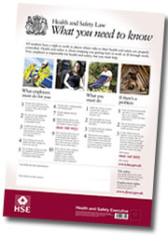

Our charity has established effective lines of communication so as to involve and consult our employees.

These may include:

* individual conversations
* notice boards
* internal publications
* staff meetings
* Health and Safety meetings.

In addition the charity will display the ‘Health and Safety Law – What You Need To Know’ poster in a prominent position.

The charity will consult with our employees and provide information on any changes that may affect their health and safety, including:

* changes in procedures, equipment or ways of working
* the dangers and risks arising from their work activities, the measures taken to eliminate or reduce these risks and what action to take if they have to deal with them
* the planning of health and safety training
* the health and safety consequences of introducing new technology.

The charity recognises that consultation is a two-way process and expects constructive feedback from our employees.

## Contractors

When working on our premises it is considered that contractors are joint occupiers for that period and therefore we have both joint liabilities in “common areas”. In order to meet our legal obligations with regard to contractors we will ensure that prior to engaging any contractor they are competent and that any works are carried out safely.

Similarly we have a parallel duty to the contractor and must ensure that the contractor is not put at risk by our own activities for the duration of the contract.

If you observe contractors who appear to be working unsafely then you should report this immediately to a manager / supervisor. We will investigate and where necessary stop any work until resolved.

## Disabled Persons

The charity will give full and proper consideration to the needs of disabled employees and visitors.

To achieve this, the charity will:

* treat all disabled employees and visitors with respect and dignity, both in the provision of a safe working environment and in equal access to the organisation’s facilities
* ensure that risk assessments are undertaken of the special needs of the disabled and carry out reasonable adjustments to the premises and/or employment arrangements
* encourage employees with special needs to suggest any premises or task improvements to their line managers
* discipline any employees found treating their disabled colleagues with less than the expected standards of respect and dignity
* in an emergency evacuation, ensure suitable plans are in place which will assist disabled people to leave the premises swiftly.

## Display Screen Equipment

All reasonable steps will be taken by the charity to secure the health and safety of employees who work with display screen equipment.

To achieve this objective the charity will carry out an assessment of each user’s workstation and implement necessary measures to remedy any risks found as a result of the assessment.

**Eye Tests and Corrective Appliances**

The charity will arrange for the provision of free eye tests when requested and at regular intervals thereafter or where a visual problem is experienced, at no cost to the employee. Where employees require corrective appliances specifically for use with display screen equipment, the charity will arrange for the supply of corrective appliances up to current cost limits.

**Training**

Employees working with display screen equipment (DSE) should comply with the instructions and training given regarding safe workstation set-up and use, including the need for regular changes of activity or breaks and the use of the equipment provided.

**Health**

Employees should inform their departmental supervisor/line manager of any disability or health condition which may affect their ability to work using display screen equipment or be affected by working with DSE. In addition they should also report to their departmental supervisor/line manager any discomfort or health concern believed to be associated with the use of DSE. Any health information will be treated confidentially.

## Driving for Work

Driving is an integral part to some roles within the charity and as such requires driving on charity business. Driving has inherent risks associated with it which drivers should be made aware of.

The charity is committed to reducing the risks its staff face or create when driving at work and requires its entire staff to play their part, whether they use a charity vehicle, their own or a hire vehicle.

**Drivers**

Drivers will remain responsible for their safety and others and must comply with the Highway Code and Road Traffic Act.

It is the responsibility of drivers to inform their manager of:

* anything that could affect their driving e.g. health conditions or injuries, use of prescribed medication
* changes to licence such as; limitations, offences recorded, period bans
* vehicle defects that affect ability / safety to drive
* any accidents / incidents that occurred whilst driving on behalf of the charity.

Before driving, drivers must

* review the need to travel
* have a valid licence for the vehicle they are driving and for any overseas travel if required
* ensure valid insurance for business use
* carry out a pre-use vehicle check
* allow sufficient time to drive allowing for traffic, poor weather and rest breaks
* ensure sufficient rest
* be physically fit, with zero alcohol level and not under the influence of drugs that may affect the ability to drive
* have had an eye test in last 2 years and be using any corrective appliance
* adjust their driving position, head restraints and mirrors to ensure maximum comfort and safety.

Whilst driving, drivers must

* drive in accordance with the applicable law and with consideration for the safety of passengers and other road users
* take regular rest breaks every 2-3 hours or at first signs of tiredness
* remain in control of the vehicle at all times
* not smoke in a charity vehicle
* only use hands free electronic devices e.g. mobile phone, satellite navigation, mp3 player, when safely set up to do so i.e. using an appropriate hands-free device
* follow all safety instructions when taking their vehicle on board ferries, trains or other vehicle-carrying craft, including parking and leaving their vehicle on a vehicle deck and travelling in a designated passenger area while the craft is underway.

## Electricity

All reasonable steps will be taken to secure the health and safety of employees who use, operate or maintain electrical equipment.

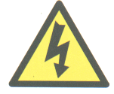

Employees must:

* visually check electrical equipment for damage before use
* report any defects found to their line manager/supervisor
* not use defective electrical equipment
* not carry out any repair to any electrical item unless qualified to do so
* switch off non-essential equipment from the mains when left unattended for long periods
* not bring any electrical item onto the charity premises until it has been tested and a record of such a test has been included in the appropriate record
* not leave electric cables in such a position that they will cause a tripping hazard or be subject to mechanical damage
* not carry out any live working unless authorised to do so under a permit-to-work.

## Fire

All reasonable steps will be taken to prevent a fire occurring. In the event of fire, the safety of life will override all other considerations, such as saving property and extinguishing the fire.

The charity does not require persons to attempt to extinguish a fire but extinguishing action may be taken if it is safe to do so. Immediate evacuation of the building must take place as soon as the evacuate signal is given. All occupants, on evacuation, should report to the pre-determined assembly points.

Re-entry of the building is strictly prohibited until the fire brigade officer or a senior person present declares it is safe to do so.

Employees are encouraged to report any concerns regarding fire procedures so the organisation can investigate and take remedial action if necessary.

Only fire blankets and the following types of fire extinguisher are currently present on site. Other types of extinguishers will be added to this chart if they are required on site.

|  |  |  |  |  |  |  |  |  |
| --- | --- | --- | --- | --- | --- | --- | --- | --- |
| **Fire Extinguisher Chart** | | | | | | | | |
| Extinguisher | | Class of Fire | | | | | | |
| **Colour** | **Type** | **\\walnut\Users\martincrowther\My Documents\Class A Fire.JPG**  **Solids** | **\\walnut\Users\martincrowther\My Documents\Class B Fire.JPG**  **Flammable Liquids** | **\\walnut\Users\martincrowther\My Documents\Class C Fire.JPG**  **Flammable Gases** | **\\walnut\Users\martincrowther\My Documents\Class D Fire.JPG**  **Flammable**  **Metals** | **\\walnut\Users\martincrowther\My Documents\Class E Electrical Fires.JPG**  **Electrical Contact** | **\\walnut\Users\martincrowther\My Documents\Class F Fire.JPG**  **Cooking Oils & Fats** | **Special Notes** |
| http://www.budget-fire.co.uk/shopimages/products/high/TG-PowerX-Water-9L.jpg  **Red** | **Water** | **Yes**  **Yes** | **No**  **No** | **No**  **No** | **No**  **No** | **No**  **No** | **No**  **No** | Dangerous if used on 'liquid fires' or live electricity. |
| http://www.budget-fire.co.uk/shopimages/products/high/Foam-3ltr.jpg  **Cream** | **Foam** | **Yes**  **Yes** | **Yes**  **Yes** | **No**  **No** | **No**  **No** | **No**  **No** | **No**  **No** | Not practical for home use. |
| http://www.budget-fire.co.uk/shopimages/products/high/thomas-glover-9kg-powerx-powder-fire-extinguishers.jpg  **Blue** | **Dry**  **Powder** | **Yes**  **Yes** | **Yes**  **Yes** | **Yes**  **Yes** | **No**  **No** | **Yes**  **Yes** | **No**  **No** | Safe use up to 1000v. |
| http://www.budget-fire.co.uk/shopimages/products/high/2kg-co2-fire-extinguisher-UF.jpg  **Black** | **Carbon Dioxide (CO2)** | **No**  **No** | **Yes**  **Yes** | **No**  **No** | **No**  **No** | **Yes**  **Yes** | **No**  **No** | Safe on high and low voltages |
| **Colour** | **Type** | **\\walnut\Users\martincrowther\My Documents\Class A Fire.JPG**  **Solids** | **\\walnut\Users\martincrowther\My Documents\Class B Fire.JPG**  **Flammable Liquids** | **\\walnut\Users\martincrowther\My Documents\Class C Fire.JPG**  **Flammable Gases** | **\\walnut\Users\martincrowther\My Documents\Class D Fire.JPG**  **Flammable**  **Metals** | **\\walnut\Users\martincrowther\My Documents\Class E Electrical Fires.JPG**  **Electrical Contact** | **\\walnut\Users\martincrowther\My Documents\Class F Fire.JPG**  **Cooking Oils & Fats** | **Special Notes** |

## Fire and Emergency Evacuation

|  |  |
| --- | --- |
| **IF YOU DISCOVER A FIRE:** | |
|  | **Operate the nearest fire alarm call point.**  IF IT IS SAFE TO DO SO AND IF YOU HAVE AUTHORISATION AND APPROPRIATE TRAINING, attack the fire with the fire fighting equipment provided  Always ensure there is a safe exit route before attempting to extinguish any fire.  Leave the building immediately if you cannot control the fire or your escape route is threatened. |
| **ON HEARING THE ALARM:**  The fire alarm sound is a **bell**. | |
|  | **Immediately vacate the premises by the nearest available exit**  Close all windows and doors behind you |
|  | **Go to assembly point**  Report to the person in charge of your assembly point  The assembly point is located:  **car park** |
|  | DO NOT RE-ENTER THE BUILDING TO COLLECT PERSONAL BELONGINGS.  DO NOT RE-ENTER THE BUILDING UNTIL TOLD TO DO SO BY THE SENIOR  PERSON PRESENT |

**VISITORS**

All visitors should be escorted to the assembly point by their host.

It is important that they do not leave the area before notifying the senior person present.

**LIAISING WITH EMERGENCY SERVICES**

The senior person present will meet and liaise with the emergency services and any other interested parties, giving them pertinent information related to the emergency situation, such as location and details of emergency, location and presence of hazardous and flammable materials, head count statistics, etc.

## First Aid

[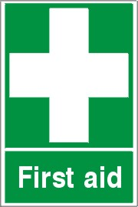](http://www.signgallery.co.uk/popup.cfm?p_n=268385&p_i=268385)The charity is committed to providing sufficient provision for first aid to deal with accidents and injuries that arise at work. To achieve this objective the charity will appoint and train a suitable number of first aid personnel to cover all work patterns and communicate their identities to all staff.

If you are interested in becoming a first aider or appointed person, please inform your manager/supervisor.

Should you require first aid treatment, please contact your nominated first aider/appointed person. Please ensure all accidents have been recorded accordingly.

**First Aid supplies**

A first aid box will be provided and should be kept stocked. If you use any of the contents please inform the persons responsible for the contents. Portable first aid kits will be available for staff members required to work away from the normal workplace, where access to facilities may be restricted.

## Gas Installations and Appliances

The charity will ensure that all work carried out on gas fittings and 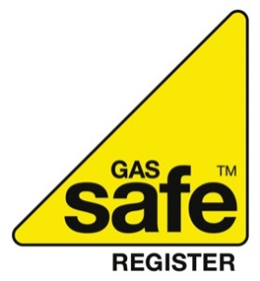appliances are in accordance with the requirements of the regulations and the Safety in the Installation and Use of Gas Systems and Appliances Manual.

The Gas Safe Register (GSR), formerly CORGI, is the governing body approved by the Health and Safety Executive to register and monitor the activities of gas installation and use. Gas fitting operatives carrying out work on behalf of the charity will be registered with the GSR.

No person shall interfere with any gas appliance or gas fitting or pipe work unless qualified and competent to do so.

**Gas Leak Procedure**

If you smell gas or suspect you have a gas emergency you **MUST** follow the steps below:

**DO NOT**

* operate any electrical switches (on or off)
* smoke or use a naked flame
* turn the gas back on until the leak has been repaired.

**DO**

* extinguish all naked flames
* open doors and/or windows to ventilate the area
* check your gas appliances and turn them off
* turn the gas supply off at the main meter
* telephone the National Grid Emergency Service
* evacuate the building
* report to the Fire Assembly Point.

**Fire**

If a gas leak results in a fire on the premises:

* **IMMEDIATELY** activate the fire alarm, evacuating premises
* **TELEPHONE** the Fire Brigade
* **ISOLATE** the gas supply at the main meter if safe to do so
* **TELEPHONE** the National Grid Emergency Service.

## Hazardous Substances (COSHH)

All reasonable steps will be taken to ensure all exposure of employees to substances hazardous to health is prevented or at least controlled to within statutory limits.



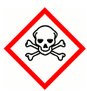The charity will give sufficient information and training to ensure full understanding of the hazards to health posed by substances in the workplace and the importance of the control measures provided. Information will also be given to others who may be affected such as contractors, temporary staff and visitors where appropriate.

Employees should **not** use any hazardous substance unless they have received the information and training for the safe use of that substance.

## Health, Safety and Welfare

The charity is committed to providing suitable health, safety and welfare facilities in line with current legislation, in particular the provision of:

* adequate maintenance of workplace and equipment
* appropriate ventilation, temperature control and lighting
* suitable cleanliness and housekeeping standards
* adequate workspace allocation
* properly designed workstations
* well maintained traffic routes and floors
* appropriate fall protection
* suitable glazing
* safe access and egress (well maintained exits and entrances)
* appropriate sanitary and washing facilities
* separate toilet facilities for men and women
* plentiful drinking water supply and cups
* seating with an incorporated back rest
* accommodation for keeping clothing clean and dry
* facilities for changing, rest periods, hot drinks and meals preparation
* showering facilities if the nature of an employees work requires this
* appropriate first aid provision
* appropriate emergency, fire and evacuation equipment and procedures.

The charity recognises these responsibilities are required for any work whether on a remote work site, at their usual workplace or head office.

## Home Working

Home workers are subject to the same health and safety requirements as workers based on charity premises and their health and safety will be managed accordingly.

If you are a home worker, then you will be required to complete an assessment annually to review any requirements identified.

The assessment will review (but not limited to), equipment supplied, electrical testing, training, interaction with colleagues, communication.

Training

All home workers will be fully trained in the tasks that they are employed to do and the equipment they will be using.

## Infection Control

For some work activities, staff may be at risk of infection or of spreading infection. The charity aims to prevent the spread of infection through work-based activities by adopting suitable control measures.

Employees must:

* follow any procedures set out and good hygiene practices
* wear personal protective equipment (PPE) as directed.

**Vaccination**

Employees at risk of infection will where possible be offered vaccinations without charge. Please contact your manager/supervisor to make arrangements.

**Training and Information**

Training and information will be provided to all employees who are identified from the risk assessment as being potentially exposed to infections. Training will be given for any tasks they are employed to do, the equipment they will be using and any safe procedures to adopt.

**Staff Illness and Reporting**

It is important to remember that infection can also be passed onto people from staff. Staff should notify their manager if they develop any infectious disease that may affect work or people around them, for example:

* skin infections or exposed areas of infestation
* severe respiratory infection (e.g. pneumonia, TB)
* severe diarrhoea
* jaundice
* hepatitis
* chicken pox, measles, mumps, rubella
* norovirus
* gastroenteritis

Managers will need to discuss with the individual suitable controls. In some cases, employees may need to be referred to an Occupational Doctor or their GP for advice.

Staff should also report any illness or disease which has been contracted through work. In some circumstances if a staff member contracts a disease whilst at work, this is reportable under RIDDOR (Reporting of Injuries, Diseases and Dangerous Occurrences Regulations). Certain diseases including Leptospirosis, Hepatitis, TB, and Tetanus are specifically required to be reported.

**Confidentiality**

Confidentiality will be maintained at all times in relation to an employee who is known to have any infectious disease.

No health information will be disclosed without the written consent of the employee concerned and any breach of such confidentiality, either inside or outside the organisation, will be regarded as a disciplinary offence and may result in disciplinary action.

**Pandemics and Epidemics**

When notified that the country is experiencing a pandemic or epidemic, the charity will aim to prevent the spread of infection through work-based activities by adopting suitable control measures.

Employees must:

* assist the charity with implementing measures specified by government agencies, including adopting alternative methods of working such as home working where needed,
* use any required personal protective equipment (PPE) as instructed,
* ensure that they inform the charity about any relevant changes to their medical circumstances, and
* adopt good hygiene practices.

## Legionnaires’ Disease

All reasonable steps will be taken to identify potential legionellosis hazards and to prevent or minimise the risk of exposure.

At risk systems include the hot and cold water storage and distribution system.

To achieve control of legionella bacteria the charity will implement measures to ensure any growth of the bacteria is kept to a minimum and systems maintained.

## Lone Working

The charity will ensure, so far as is reasonably practicable, that employees and self-employed contractors who are required to work alone or unsupervised for significant periods of time are protected from risks to their health and safety.

Employees and others will be given all necessary information, instruction, training and supervision to enable them to recognise the hazards and appreciate the risks involved with working alone.

Employees will be required to follow the safe working procedures devised including:

* when working alone, e.g. in an isolated area of a building with all doors closed, ensure that someone is aware of your presence
* check that work being done has been subject to risk assessment and check the assessment yourself – some work may have been identified as requiring the assistance of a second person
* if possible and arranged beforehand, keep in regular contact with someone else, e.g. use a mobile phone to call into the office every couple of hours indicating your movements
* do not put yourself at risk; if you do not feel safe discuss the situation with your immediate manager
* report all accidents, injuries, near-misses and dangerous occurrences to your immediate manager.

## Manual Handling

To prevent injuries and long term ill-health from manual handling the charity will ensure that operations which involve manual handling are eliminated, so far as is reasonably practicable. Where it is not practical the charity will carry out an assessment to determine what control measures are required to reduce the risk to an acceptable level. In considering the most appropriate controls, an ergonomic approach to designing the manual handling operation will optimise the health, safety and productivity associated with the task.

**Information and Training**

Adequate information and training will be provided to persons carrying out manual handling activities including details of the approximate weights of loads to be handled and objects with an uneven weight distribution.

**Health**

No employee will be required to lift any item that they do not feel confident of doing without risking personal injury.

Employees who have a medical condition that may prevent them undertaking a task should notify their Manager / Supervisor beforehand. Should you become injured whilst handling anything then this must be reported to your Manager/Supervisor so it can be suitably investigated.

## New and Expectant Mothers

The charity recognises that the general precautions taken to protect the health and safety of the workforce as a whole may not in all cases protect new and expectant mothers and there may be occasions when, due to their condition, different and/or additional measures will be necessary.

Should you become pregnant or are returning to work after having a baby, then you are requested to notify your manager at the earliest possible opportunity so a risk assessment can be carried out.

Any necessary control measures will be implemented and reviewed regularly. Where risks cannot be eliminated or reduced to an acceptable level then consideration will be given to adjusting working conditions and/or hours or if necessary providing suitable alternative work or suspension with pay.

New or expectant mothers should inform their manager of any changes which may affect the risk assessment including any medical conditions, incidents etc.

## Personal Protective Equipment

The charity provides personal protective equipment (PPE) when the risk presented by a work activity cannot be eliminated or adequately controlled by other means. When it is provided, it is because health and safety hazards have been identified that require the use of PPE and it is therefore necessary to use it in order to reduce risks to a minimum.

Employees provided with PPE must:

* wear the PPE as instructed or where indicated by signage
* maintain it in good condition
* report any defects to your supervisor/manager
* ensure the PPE fits correctly, is comfortable and fully adjusted.

Employees may also be required to remove jewellery or other small items when using PPE. Employees must remove such items as instructed; employees with concerns about removing items worn for ethical, philosophical or cultural reasons should speak to their supervisor.

## Risk Assessment

Risk Assessment involves identifying the hazards present in the work place or arising out of any work activity, and evaluating the extent of the risks involved to employees and others, taking into account existing precautions and their effectiveness. The charity will arrange for competent people to carry out risk assessments of all activities, substances, equipment, plant or working conditions likely to give rise to a significant risk of injury or ill health.

Employees will be advised as to the results of the risk assessment process and the additional control measures to be implemented to reduce risk to an acceptable level. Employees are expected to support the risk assessment process and adopt any changed controls implemented to reduce risk to an acceptable level.

## Smoking

Exposure to second-hand smoke, also known as passive smoking, increases the risk of lung cancer, heart disease and other illnesses. Ventilation or separating smokers and non-smokers within the same airspace does not stop potentially dangerous exposure.

It is the policy of the charity that all of its workplaces are smoke-free and that all employees have a right to work in a smoke-free environment.

Smoking is prohibited throughout the entire workplace and this includes the use of all artificial smoking aids (electronic or otherwise) with no exceptions. This includes charity vehicles that are used by more than one employee. If you have a charity car that is designated for your sole use and that is never used by other employees then you can smoke in it if you wish – but the charity recommends that you do not do so. This policy applies to all employees, customers and visitors.

**Implementation**

All staff are obliged to adhere to and facilitate the implementation of the policy.

The charity will ensure that all employees and contractors are aware of the policy on smoking. They will also ensure that all new personnel are given a copy of the policy on recruitment or induction.

Appropriate 'no smoking' signs will be clearly displayed at or near the entrances to the premises. Signs will also be displayed in charity vehicles that are covered by the law.

## Stress at Work

The Health and Safety Executive define stress as “the adverse reaction people have to excessive pressure or other types of demand placed on them”. This makes an important distinction between pressure, which can be a positive state if managed correctly, and stress which can be detrimental to health.

Stress at work can come about for a variety of reasons. It may be excessive workload, unreasonable expectations, or overly-demanding work colleagues. As a reasonable charity, we try to ensure that you are in a pleasant working environment and that you are as free from stress as possible.

Employees who experience unreasonable stress which they think may be caused by work should raise their concerns with their Manager or through the charity’s grievance procedure. If deemed appropriate, the charity will provide access to confidential counselling for employees affected by stress caused either by work or external factors

Following action to reduce the risks, they shall be reassessed. If the risks remain unsustainable by the employee concerned, efforts shall be made to reassign that person to other work for which the risks are assessed as tolerable.

## Training

Training in health and safety is a legal requirement and also helps create competent employees at all levels within the charity to enable them make a far more effective contribution to health and safety, whether as individuals, teams or groups.

All employees will receive **induction training**.

Such training will cover:

fire procedures, warning systems, actions to be taken on receiving warning, locations of exits/escape routes, evacuation and assembly procedures, first aid/injury reporting procedures, names of first aiders/appointed persons, instruction on any prohibition areas (i.e. no smoking), issue of protective clothing/equipment and its use, instruction under COSHH, mandatory protection areas, thorough instruction applicable to their particular duties at work etc.

Training needs will be reviewed as a result of job changes, promotion, new activities or new technology, following an accident/incident and performance appraisal.

Records of training will be kept for all employees.

Employees must:

* participate in the induction training activities they have been required to attend or carry out
* work according to the contents of any training they receive
* ask for clarification of any points they do not fully understand
* not operate hazardous plant or equipment, use hazardous chemicals or carry out any hazardous activity unless they have been appropriately trained and instructed.

## Violence to Staff

The charity recognises that in certain situations violent behaviour towards staff may occur and therefore will take all reasonable measures to protect staff from violence and aggression.

We define violence and aggression as:

* actual or threatened physical assaults on staff
* psychological abuse of staff
* verbal abuse which includes shouting, swearing and gestures
* threats against employees.

All staff must familiarise themselves with any relevant risk assessments to help them prevent violence and aggression so far as possible and to help them manage it if it occurs.

If you are a witness or receive any violence or aggression towards you, then you should report this to your manager / supervisor so that this can be recorded and investigated. The charity will support the decision of any employee wishing to press charges against the individual(s) involved. Access to counselling can also be provided where required.

## Visitors

In the interest of safety and security, the charity will take the necessary measures to protect staff and visitors from any accidents or incidents that may occur during visiting.

Employees hosting visitors must ensure that:

* they are authorised to enter the premises or are accompanied
* they adhere to applicable health and safety instructions and rules during their visit
* adequate information is passed to ensure their safety including emergency information
* any protective clothing required is provided and worn
* any accidents / incidents involving visitors are reported through the accident reporting arrangements.

Employees aware of people on the premises who may be unauthorised should report these to their manager for action.

**Emergency Action**

In the event of the fire alarm sounding, all visitors should be escorted to the assembly point by their host. Visitors should not leave the area before notifying the senior person present.

## Work At Height

The charity will take all reasonable steps to provide a safe working environment for all employees who may be affected by work at height activities.

The need to undertake work at height will be eliminated whenever it is reasonably practicable to do so. Where not practical, then the charity will ensure that all work activities that involve work at height are identified and assessed.

If working at height you must ensure that:

* the task has been assessed
* suitable safety measures are in place
* any equipment being used has been erected by a competent person and is safe to use
* you only use equipment for which you have been trained and are authorised to use.

Ladders are permitted for light, short duration work only and must be checked in advance of use and be secured to prevent displacement.

## Work Equipment

The charity will provide a safe working environment in relation to work equipment safety and ensure all employees receive appropriate safety information and training in their work equipment.

Employees must

* only use work equipment for which they have received information and training for
* not undertake any maintenance work unless competent and authorised to do so
* not interfere with or remove anything which has been provided for safety reasons
* report defects immediately to their manager/supervisor
* use any personal protective equipment as required.

## Young Workers

Whilst precautions taken to protect the health and safety of the workforce as a whole will, in many cases, also protect young persons, there are occasions when different and/or additional measures will be necessary due to their lack of experience, knowledge or absence of awareness of potential risks.

A ‘young person’ is defined as one who is below the age of 18 years.

To ensure the safety of young persons the organisation will:

* carry out risk assessments to cover the activities of young persons
* implement the actions determined by the risk assessment process
* inform the young persons of any risks associated with their work and the control measures taken to protect them
* provide a copy of the risk assessment to the parent/guardian of any young person below the school leaving age
* provide additional appropriate information, instruction, supervision and training, etc as determined by the risk assessment.

|  |
| --- |
| GUIDANCE |

## Control of Substances Hazardous to Health (COSHH)

There are a range of Hazardous Substances to which the regulations apply. These include:

* those classified and shown with warning label
* substances with Occupational Exposure Limits
* biological agents e.g. Legionella bacteria
* any kind of dust
* substances generated by work processes e.g. various bacteria/viruses from bodily fluids’ premises with covered or underground parking that may expose people to vehicle exhaust fumes and some manufacturing and cleaning processes that may give off dusts, vapours or fumes.

**Hazard Labelling**

Hazardous substances may be defined as being toxic, corrosive, a health hazard, a serious health hazard, flammable, oxidising, explosive, harmful to the environment or gases stored under pressure.

Classification of hazardous substances is currently done under the Classification Labelling and Packaging (CLP) Regulations, which came into full effect in June 2015. These Regulations require hazardous substances to be packaged and labelled to an internationally agreed standard.

Hazardous substances can be readily identified by their label:

|  |  |  |
| --- | --- | --- |
| **~~Irritation pictogram~~Health Hazard** | Corrosive pictogram**Corrosive** | **toxic pictogramToxic** |
| **Flammable pictogramFlammable** | **Oxidising pictogramOxidising** | **Harmful environment pictogramHarmful to the environment** |
| ~~Respiratory pictogram~~**Serious Health Hazard** | Explosive pictogram**Explosive** | **Gas pressure pictogramGases under pressure** |

Hazardous substances that are generated by work processes are not as easily identifiable as they do not come conveniently labelled. You will be informed of any hazardous substances generated by the company’s work processes.

**Exposure Routes**

Exposure to hazardous substances may be via:

* inhalation e.g. dust/ particulate or vapours/ fumes
* contact with eyes or cuts
* absorption through the skin
* ingestion
* injection.

**Hazard Effects**

Effects on health may be short-term or long-term and will generally vary according to levels and duration of exposure. Effects of substances also vary with some having an accumulative effect and some that will have only temporary health effects.

**Control Principles**

The principles applied to substances to control exposure are:

* 1. elimination e.g. don’t use the substance
  2. substitution e.g. a less hazardous substances
  3. engineering controls e.g. Local Exhaust Ventilation
  4. information, instruction, supervision and training
  5. Personal Protective Equipment (PPE) e.g. gloves, glasses, overalls.

**Working with Hazardous Substances**

Prior to working:

* ensure you understand the risks of working with any hazardous substances and the controls in place
* ensure you know the location of the material safety data sheets and risk assessments
* ensure the controls specified in the risk assessment, including any items for emergencies are:
  + in place
  + fully operational
  + available.
* ensure you understand how to operate or use any control measures safely and have received training prior to starting work.

Whilst working

* ensure regular check controls are effective
* clean up any spillages etc
* report any problems or defects immediately to your manager
* report any ill-health or accidents to your manager.

## Display Screen Equipment (DSE)/Visual Display Unit (VDU)

**Some practical tips:**

**Getting Comfortable**

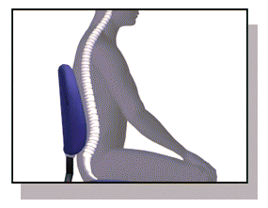

* Adjust your chair and VDU to find the most comfortable position for your work. As a broad guide, your lumbar should be supported by the seat cushion, forearms should be approximately horizontal and your eyes the same height as the top of the VDU.
* 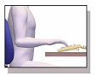Make sure you have enough work space to take whatever documents or other equipment you need.
* Try different arrangements of keyboard, screen, mouse and documents to find the best arrangement for you. A document holder may help you avoid awkward neck and eye movements
* 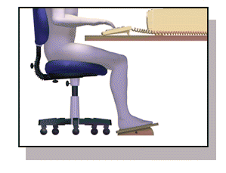Arrange your desk and VDU to avoid glare, or bright reflections on the screen. This will be easiest if neither you nor the screen is directly facing windows or bright lights. Adjust curtains or blinds to prevent unwanted light
* Make sure there is space under your desk to move your legs freely. Move any obstacles such as boxes or equipment
* Avoid excess pressure from the edge of your seat on the backs of your legs and knees. A footrest may be helpful, particularly for smaller users.

**Keying in**

* Adjust your keyboard to get a good keying position. A space in front of the keyboard is sometimes helpful for resting the hands and wrists when not keying.
* Try to keep your wrists straight when keying. Keep a soft touch on the keys and don’t overstretch your fingers. Good keyboard technique is important.

**Using a mouse**

* Position the mouse within easy reach, so it can be used with the wrist straight. Sit upright and close to the desk, so you don’t have to work with your mouse arm stretched. Move the keyboard out of the way if it is not being used.
* Support your forearm on the desk, and don’t grip the mouse too tightly.
* Rest your fingers lightly on the buttons and do not press them hard.

**Reading the screen**

* Adjust the brightness and contrast controls on the screen to suit lighting conditions in the room.
* Make sure the screen surface is clean.
* In setting up software, choose options giving text that is large enough to read easily on your screen, when you are sitting in a normal, comfortable working position. Select colours that are easy on the eye (avoid red text on a blue background, or vice-versa).
* Individual characters on the screen should be sharply focused and should not flicker or move. If they do, the VDU may need servicing or adjustment.

**Posture and Breaks**

* Don’t sit in the same position for long periods. Make sure you change your posture as often as practicable. Some movement is desirable, but avoid repeated stretching to reach things you need (if this happens a lot, rearrange your workstation).
* Most jobs provide opportunities to take a break from the screen, e.g. to do filing or photocopying. Make use of them. If there are no such natural breaks in your job, your employer should plan for you to have rest breaks. Frequent short breaks are better than fewer long ones.

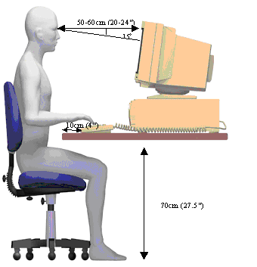

## Electrical Safety

**What are the hazards?**

The main hazards are:

* contact with live parts causing shock / burns (normal mains voltage, 230 volts AC, can kill)
* faults which could cause fires
* fire or explosion where electricity could be the source of ignition in a potentially flammable or explosive atmosphere, e.g. in a spray paint booth

Ensure that:

* suspect or faulty equipment is taken out of use, labelled ‘DO NOT USE’ and kept secure until examined by a competent person
* where possible, equipment, tools and power socket-outlets are switched off before plugging in or unplugging
* equipment is switched off and/or unplugged before cleaning or making adjustments.

**Visual checks on electrical equipment**

1. Inspections and testing of all portable electrical equipment and the fixed electrical installations is the responsibility of the charity, though the responsibility for undertaking visual checks falls to all employees.

2. Around 95% of all faults or damage can be found by visual checks and this will involve checking:

|  |  |
| --- | --- |
| * for damage to the cable covering, such as cuts and abrasions, apart from light scuffing, or non-standard repairs e.g. cable wrapped with electrical tape |  |
| * where the cable enters the plug. Internal wires - those covered by the outer sheath may be exposed or the cable may be loose and move within the plug |  |
| * for damage to the plug, such as the cracked casing, bent pins, evidence of overheating i.e. burn marks or discoloration |  |

* for damage to the sockets, switches, etc. e.g. cracked or broken casing
* that equipment has been used in conditions for which it is not suitable, e.g. a wet or dusty workplace or has damage to the outer cover of the equipment or has obvious loose parts or screws
* cables are routed safely, with the one extension lead used per socket. Where there is a risk of tripping over cables and they cannot be re-routed, cable strips must be fitted.

## Hand Washing

It is important to look after your skin. Wash hands using steps below to remove any contamination from your skin promptly, and remember to thoroughly dry your skin after washing. Using moisturising creams can also help to protect your skin.

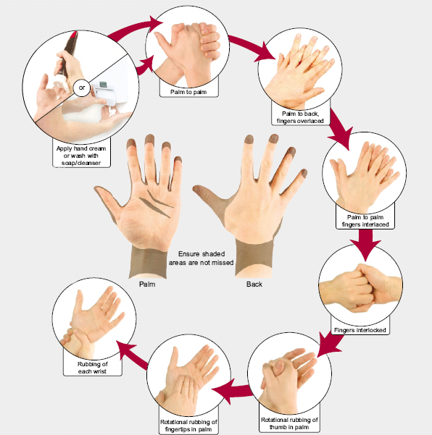

Regularly check your skin for dermatitis. Look for signs of dryness, itching and redness.  If you think you may have dermatitis, report it to your supervisor.

## Manual Handling

**PRINCIPLES OF GOOD HANDLING TECHNIQUE**

1. **Planning**

Plan the lift and consider: where the load is to be placed, what are the distances involved, are there any obstructions such as closed doors, is assistance required, and can handling aids or equipment be used?



1. **Feet**

The feet should be positioned a shoulder width apart, one foot ahead of the other in the direction of the intended movement.



1. **Knees**

Adopt a good posture for handling with the knees bent (not squat – don’t kneel), in order to gain the most effective power from the thigh muscles.

1. **Back**

The back should be straight (not necessarily vertical, 15 - 20o from vertical is alright) keeping the natural curve of the spine. It may help to tuck in the chin. If necessary, lean forward a little over the load to get a good grip and to keep the centre of gravity over the load.

1. **Arms**

The arms should be close to the body (nearer the centre of gravity) with the shoulders level and facing the same direction as the hips.



1. **Hands**

Ensure a firm grip on the load using the roots of the fingers and the palm of the hand. Holding the load this way is also less tiring than keeping the fingers straight.

1. **Head**

Raise the chin out and up as the lift begins, otherwise this results in round shoulders and a curved spine.

**8 Moving the Load**

Keep the load as close to the trunk for as long as possible, and where relevant, keep the heaviest side of the load close to the body. Slide the load towards you if required.

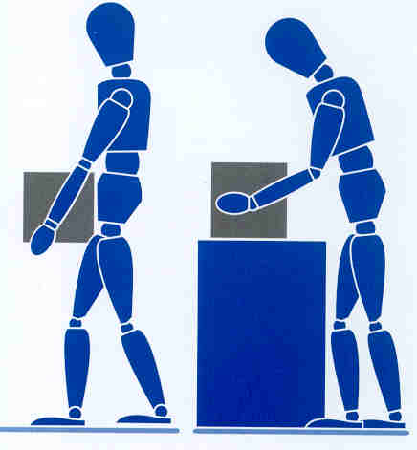

* Lift smoothly
* Move the feet not the trunk when turning to the side i.e. don’t twist.
* Put the load down and then slide the load into the required position if necessary.

9 Team handling

Handling by two or more people may make possible an operation that is beyond the capability of one person or reduce the risk of injury to a solo handler.

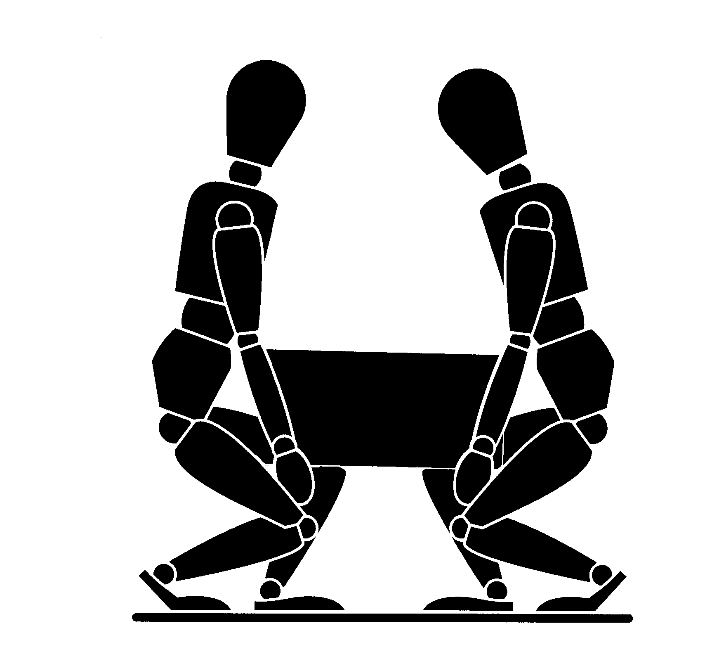

Additional difficulties may arise if team members impede each other’s vision or movement, or if the load offers insufficient good handholds. This can occur particularly with compact loads which force the handlers to work close together or where the space available for movement is limited.

When lifting loads at or near floor level is unavoidable, it is preferable to use handling techniques which allow the use of relatively strong leg muscles rather than those of the back, provided the load is small enough to be held close to the trunk. In addition, if the task includes lifting to shoulder height, allow the handlers to change hand grip. Bear in mind however, that such techniques impose heavy forces on the knees and hip joints which must carry both the weight of the load and the weight of the rest of the body.

The closeness of the load to the body can also be influenced by foot placement. The elimination of obstacles which need to be reached over or into will permit the handler’s feet to be placed beneath or adjacent to the load before beginning the manual handling operation.

|  |
| --- |
| HEALTH AND SAFETY HANDBOOK ACKNOWLEDGEMENT FORM |

Please read the notes below and then sign this form.

Clearly, we will do all in our power to ensure the health and safety and welfare of all our staff and we look to our employees to abide by the Health and Safety standards laid down.

We have formulated our Health and Safety at Work Policy as legally required and this handbook informs you of those sections of the Policy which affect you.

You should read the information contained in this Handbook and adhere to the rules at all times.

Please discuss any queries you may have with your employer and sign this form.

***I have read the Health and Safety Handbook and understand and accept its contents. I will keep myself informed of its contents.***

|  |  |  |  |
| --- | --- | --- | --- |
| Signature: |  | Date: |  |

|  |  |
| --- | --- |
| Print Name: |  |